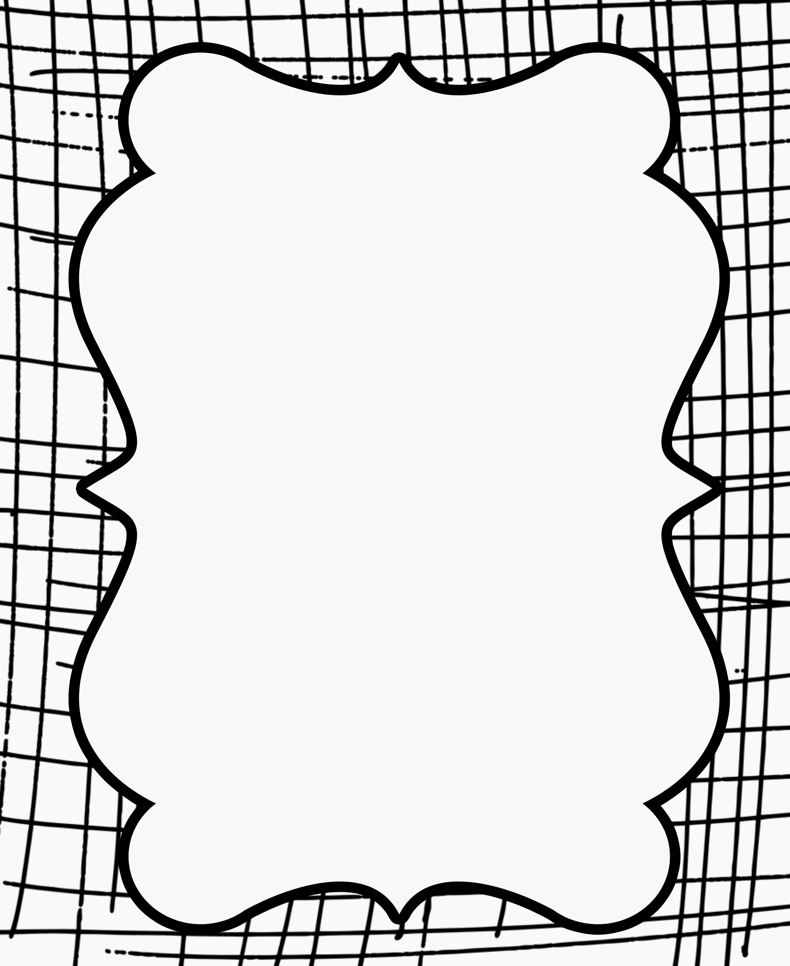

first

do

eat

mother

saw

what

after

there

make

did

father

night