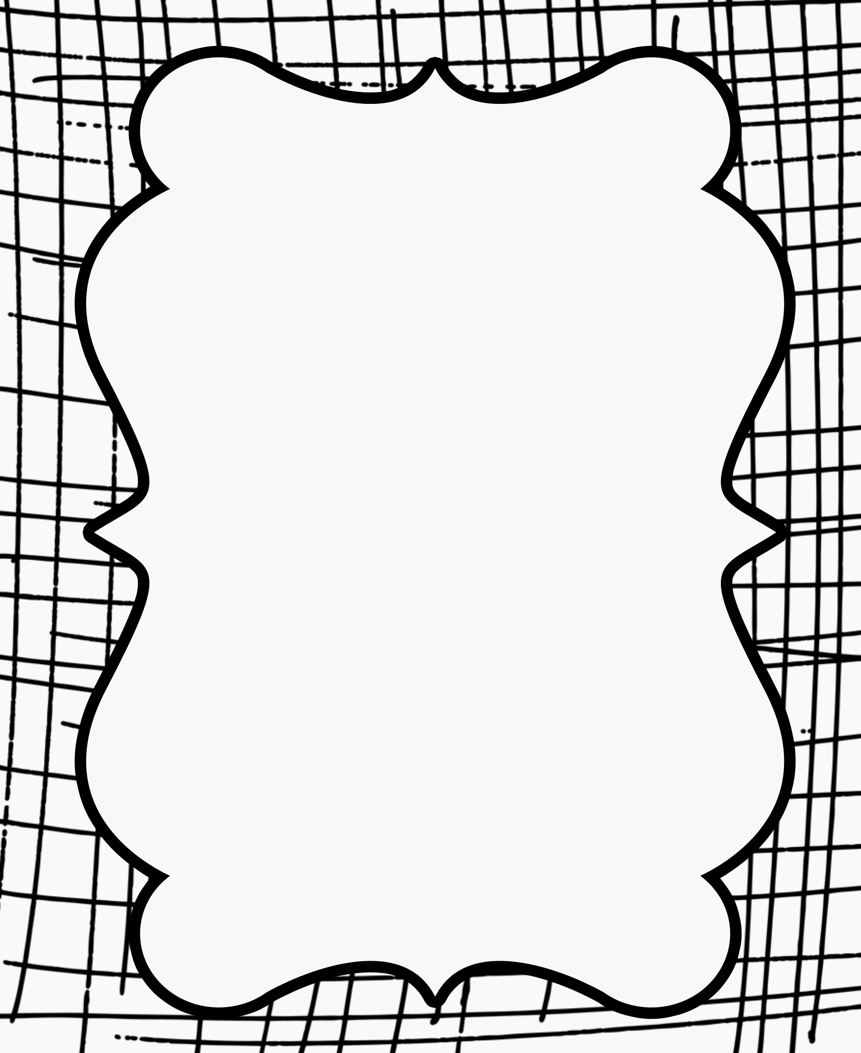

here

up

go

see

my

because

you

look

the

said

we

on